**Brushless motors**

The internal workings of a brushed and a brushless motor is the same; both are based on electromagnetism.

When the motor windings become energized (both the motors have coils), a temporary magnetic field is created that repels (and/or attracts) against the permanent magnets present inside the motor.

This magnetic force is creating the repulsive force in the coil that is used to spin/rotate the shaft.

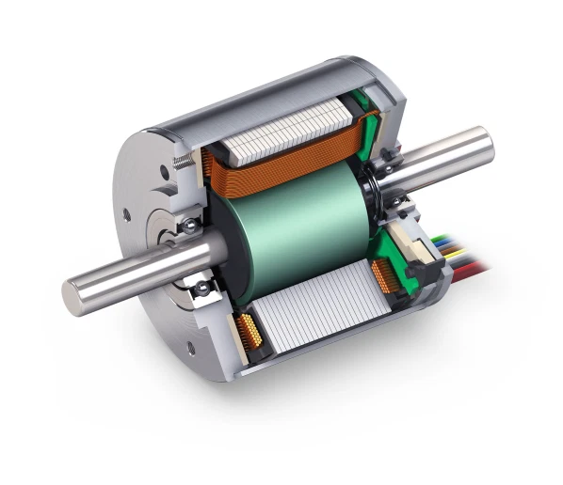

The internal workings of a brushed and a brushless motor is the same; both are based on electromagnetism.

When the motor windings become energized (both the motors have coils), a temporary magnetic field is created that repels (and/or attracts) against the permanent magnets present inside the motor.

This magnetic force is creating the repulsive force in the coil that is used to spin/rotate the shaft.

**The basics of brushless motor**

There are 2 major parts for a brushless motor called stator and a rotor.

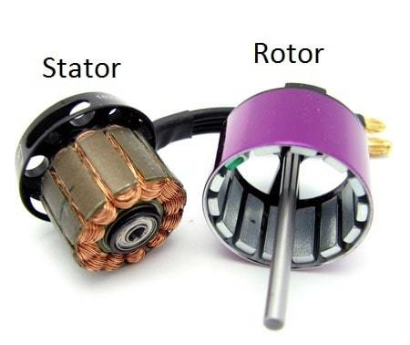

The stator is the stationary part of the motor(windings) and the rotor is the rotatory part of the motor(bell with magnets). Also there are a lot of other minor things such as bearings, coil, magnets, shafts etc.

A motor size is based on the stator size (diameter and height).. For example if a motor is sized as 2207, it means that the stator is 22mm in width and has 07mm in stator height.

Also there is something called as a KV of a motor. What it means is that the speed at which the motor rotate for every volt applied to the motor, theoretically.

**Thrust to Weight Ratio**

Brushless motors come in all shapes and sizes. The general rule of thumb is to aim for 2:1 thrust to weight ratio. You aren’t going to be able to do hard core racing with it. The higher the better obviously. The thrust to weight to ratio depends mostly on the size of the quads themselves.

There are pre built quads such as from Diatone Crusader GT which has a thrust to weight ratio of 8:1. There are people who have achieved 13:1. But there are certain limitations for the motors, because they can only spin so fast and spinning them any faster makes them inefficient.

Even for a photography rig you should aim at least for 3 or 4:1 in case you decide to upgrade your setup in the future or add an HD camera or a bigger battery for longer flight times or something, then you’ll have some reserve power left to compensate.

For a drone racing beginner 4 or 5:1 thrust would be the sweet spot. If you’re on a tight budget then build a beast of a quad and limit the throttle limit on Betaflight or the transmitter.

A motor is indicated by a set of 4 numbers like 2207 or 2306 or whatever it may be. It denotes the diameter and the height of the rotor in millimetre (mm). The bigger the motor gets the higher the thrust it generates.

* **Taller stator** = higher top speed and terrible low speed handling
* **Wider stator** = lower top speed and better handling at lower speeds

The main cause is the increased magnetic field from the stators. The taller stators have larger magnets as compared to smaller and wider stators.

**2207 vs 2306 motors**

A good comparison would be the typical 2207 vs 2306 motors. It is a hugely debated topic as to which is better and one can’t be recommended over the other as both have their advantages and disadvantages which will be covered in another article.

### Brushless Motor Size Chart

The motor selection is determined on how large you want to build your quad. Hence the name Frame size = Motor size. By determining the frame size we can define how large of a motor we should use.

Frame size also limits the prop size and each prop requires a different motor to spin it and generate the thrust efficiently. Also the KV of a motor plays an important role in the selection of the motor. As mentioned earlier higher KV draws more current.

The table below shows the nominal frames and quadcopter motor numbers:

|  |  |  |  |
| --- | --- | --- | --- |
| **Frame Size** | **Prop size** | **Motor size** | **KV** |
| 15mm and smaller | 3” and smaller | 1105-1306 | 3000 and higher |
| 180mm | 4” | 1806 | 2600-3000 |
| 210mm | 5” | 2204-2208/2306 | 2600-3000 |
| 250mm | 6” | 2205-2208/2306 | 2000-2300 |
| 300mm | 7” | 2208/2212 | 1600 |

**Performance Factors**

### KV - Velocity Constant

Brushless motor KV rating represents the speed at which the motor rotates for every volt applied to the motor. For example if a motor is 2300kv with a 3S quadcopter battery motor applied to its ends then the motor will spin at 2600x12.60 =32,760 rpm (Revolutions per minute - number of turns in one minute), without propellers. The rpm decreases gradually because of air resistance.

Motor KV represents the speed at which the motor rotates for every volt applied to the motor.

“***Higher the KV means lower resistance and higher current draw and lower efficiencies. Lower KV means higher resistance and lower current draw and considerably better efficiencies”.***

If you’re starting out somewhere around 2300-2400 KV would be desirable.

For example, if a motor is rated at 2300kv with a 3s battery voltage applied to it, then the motor will spin at 2300x12.60 =28,980 rpm without the propellers, and it is the maximum rpm it can attain at no load.

The rpm sharply decreases when a propeller is mounted because of air resistance offered to the motor while spinning the propeller.

**Torque**

Moving on the next factor that comes into picture is the torque produced by the motor. Torque is the spinning force or the rotatory force that spins the propeller. It doesn’t matter much if you’re starting out.

Motor torque is affected by factors such as:

1. Stator size- bigger the stator higher the torque

2. Materials such as quality of magnets and copper windings in the rotor

3. Motor construction factors such as air gaps between stator and rotor.

Torque produced by the motor significantly affects the performance of the quad. It also determines how the quad is going to feel for the inputs. Higher the torque produced by the motor, the more responsive the quad will perform.

Torque also governs how fast a quad change its direction mid-flight which will greatly help to do tighter turns in a race. Relatively if a motor produces less torque and is fitted with heavier props, the motor can’t spin the propeller and resulting in reduced efficiencies and also thrust. The current draw in an over propped motor will be significantly high.

The one major disadvantage of high torque motors are even though they feel more snappy and responsive to the controls they have bad oscillation. Since motors with high torque are able to change their rpm more rapidly they actually amplify the error (oscillation).

Oscillation is hard to get rid of in Betaflight even with PID tuning,especially on the yaw axis of the quad.

### Efficiency

The efficiency of a motor is calculated by dividing the thrust produced by the motor at 100% throttle by the power produced by the motor.

This is measured by grams per watt (g/w). The higher this ratio, the more efficient the motor is essentially. We are not going to be flying 100% throttle the whole time; therefore it is important to consider the efficiency of the motor through the whole throttle range from 0% all the way up to 100% throttle.

Some motors may be efficient in the lower end of the throttle curve and some motors may be more efficient in the higher end of the throttle curve. Therefore it is important to choose the right motor depending on the style of your flying.

### Current Draw

Current drawn by the motor is important because it helps us to [determine the quadcopter esc size](https://dronenodes.com/drone-esc-electronic-speed-controller/) required for that particular motor.

For example, a 1104 motor draws 10A max at 100% throttle whereas some 2306 motors draw 40A max at 100% throttles. An esc must be selected accordingly for 20% more rating than the current drawn at 100% by the motor.

Ie; if a motor draws 30A max at 100% throttle, an esc rated for 36A constant current would be ideal.

There is also known as burst rating of an esc. It’s the maximum amps of current the esc can handle for a short period of time without damaging itself.

### Temperature

Temperature or heat in general is a killer of motors over time. If the motors are exposed to prolonged heating, the magnets in the rotor lose their magnetic field strength over time. They demagnetize over time when exposed to constant heat and consequently resulting in a reduced lifespan of the motor.

The main reasons for a motor to heat are over propping and using higher throttles for long periods of time. If you’re a pro level drone racer, you will be running at higher throttles, but if you are just starting out and the motor heats then the motor is over propped.

But motor manufacturers compensate for this issue by designing cooling fins to help the motor to suck in air into the motor and cool itself equating to longer life spans, provided you don’t crash and destroy the motor beforehand.

## OTHER FACTORS TO CONSIDER

### N and P numbers

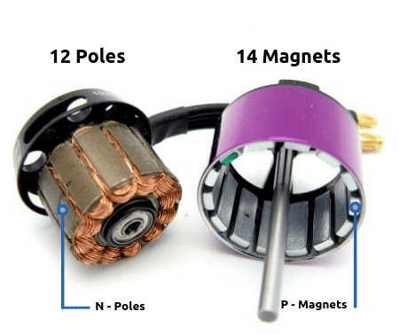

A typical 22xx or 23xx motor will have 12 poles and 14 magnets. This number will be denoted something like 12P14N. As depicted in the diagram, the poles are present on the stator and the permanent magnets are found on the rotor of a motor.

### Single & Multi stranded wires

Single stranded wires as the name suggests is made of a single wire of copper whereas multi stranded wires are made of 3 smaller wires to replace the single thicker wire. Single stranded wires are thicker and handle heat produced much better when used on high voltage builds.

Multi stranded wires break or melt easily at higher operating temperatures. Typically multi stranded wires are more efficient because they pack the wires much tighter and closer together, therefore giving stronger magnetic fields and resulting in more powerful motors.

### Magnets

The magnets in a motor play an important role in deciding how powerful a motor is going to be.

Cheap motors will have weaker magnets and produce less thrust as compared to an expensive motor which will have more powerful magnets.

Some higher-end motors even have curved magnets which are contoured to the shape of the rotor.

Magnets used in brushless motors are graded based on the magnetic strength such as N52, N54 etc…, the higher the stronger the magnetic field produced by the magnets.

### Motor windings

Another factor to consider is the quality of the windings of the motor. If the motor has high quality copper windings they’re going to offer less resistance for the flow of currents and thus offering better efficiencies and longer flight times.

### Motor Weight

The weight of a motor is governed by the size and materials of the motor. The bigger the motor the heavier it is. Keeping in mind the motors used on a 5” quad usually weigh with wires around 30-40 grams. There are some very light motors such as the Emax RSII which weigh around 25 grams for a 2306 motor with a couple of grams for the wires.

There are some very heavy motors such as the cobra 2204 motors which weigh around 34 grams. As they say, every gram counts, especially with the motors. Why? Because the moment arm increases the heavier the motor gets. Simply put it takes a significantly large amount of force to turn a quad with increase in every gram.

But that doesn’t mean lighter is better. Lighter motors are not as durable as the heavier ones because they would be made of lighter materials to save weight. Hence it all boils down to what are you going to use the motor for.

### Motor mounting patterns

The mounting patterns of a motor also matter because it should be compatible with all the frames you choose to put the motor in. Most 5” quads these days use motor sizes from 2205 to 2407.

All the motors either have (16x16) mm or (16x19) mm mounting patterns. All the modern frames support all those mounting patterns and this shouldn’t be much of a concern.

The above image shows a brushless motor in a quad. The screw holes will be present on the stator of the motor. The above-shown motor or the stator has a 16x19 mm mounting pattern and uses 4 m3 screws for securing the motor to the frame.

## FEATURES TO LOOK FOR IN MOTORS

### Motor Shaft

Newer motors nowadays use hollow shafts as opposed to a solid shaft in an attempt to reduce the weight of the motor. This has its positives and negatives.

Hollow shafts obviously reduce the weight of the motor but they’re less durable during crashes.

You can’t replace shafts without replacing the whole rotor of the motor. For budget builders, hollow shafts are a bad thing but for those looking to save every gram hollow shafts are the way to go.

### Air gap

Another thing for a better performing motor is the air gap between the stator and the rotor. The closer the rotor is to the stator (magnets to the windings) the more efficient it is in converting the current. The smaller the air gap the higher the thrust that motor produces as the stator slices through magnetic fields better.

### Motor wires

The next thing that affects the performance of a motor is the wire gauge of the motor. The motors either use 20 Awg or 18Awg (American wire gauge). The Emax RS series claim that changing from a 22 gauge to a 20 gauge wire increased the power output by 5%. But this is no big deal when buying a motor and getting started in the hobby.

### Retainer clips

The next thing we are going to talk about is the retainer clips or retaining methods of the stator and rotor. There are mainly 3 types we use in our hobby.

* E clip
* C clip
* Screw retainers

Each has their own advantages and disadvantages.

For example: E clips are difficult to remove without breaking the clip itself. Screw retainers are easily removable and hence giving easy access to the stator and rotor.

But screw retainers are prone to unscrewing and loosening over time under the constant vibration of the motor and also run the risk of over tightening the shaft and making it harder for the motor to spin. One clip can’t be recommended over the other. It all the depends on what the motor is going to be used for and its applications.

### CW CCW motors

There are 2 types of motors- clockwise (CW) and counter clockwise (CCW) rotation motors. They vary only by the direction by which they rotate with the rest of the design parameters of the motor being the same. The below diagram shows a motor orientation for a quad, hex and octa drone. We can conclude that opposite side motors spin in the same direction. It is the same in hex and octa drones.

**Brushed DC Motor**

**Brushed DC motors** are one of the simplest types of DC motor. It uses brushes to deliver current to the motor windings through mechanical commutation.

The number of coils wound around the motor and the density of the coils determine the properties of the motor. The armature or rotor is an electromagnet. The field magnet is a permanent magnet. This motor does not require any controller to operate or vary the speed.

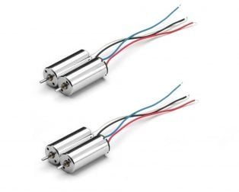

**Construction**

It typically consists of a pair of permanent magnets named as the stator and a motor coil named as the rotor connected to a [commutator](https://en.wikipedia.org/wiki/Commutator_(electric)). In this motor, [armature winding](https://www.electrical4u.com/armature-winding-pole-pitch-coil-span-commutator-pitch/) is on rotar and permanent magnets are always on the stator.

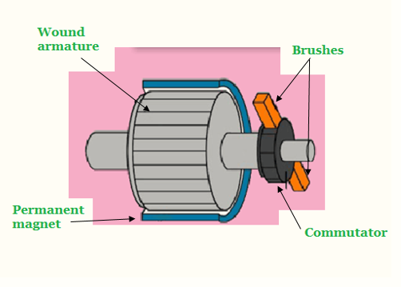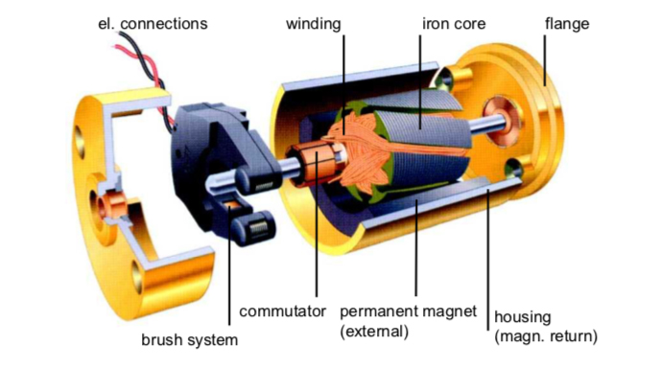

Conductors always locates on the turning part. Practically, these conductors get power from direct current power source. It uses metallic brushes (which rotate along with the rotor) to transfer the current to the coil.  Though these motors are quite efficient but they require periodic maintenance of brushes.

**Working Principles**

When power supplies to the motor through battery or any DC source, electricity flows from the source to the armature through the brushes which usually locates on opposite sides of the motors shaft. Brushes are the very important part of this motor. These brushes transfer electric current to the armature through physical contact with the commutator.

As soon as the armature coil gets energy or power, it begins to behave like a magnet. And at this point its poles start repelling the poles of the permanent magnet which makes up stator. As the poles repel, the motor shaft where the armature coil attached begins to rotate with a speed and torque. The Speed and torque depends on the strength of the magnetic field around the armature.

Usually the strength of the magnetic field is a function of the voltage applied at the brushes and the strength of the permanent magnet used for the stator.

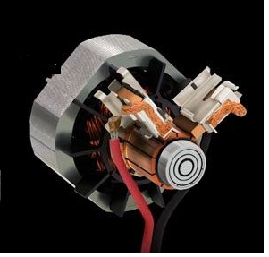

## **Advantages of Brushed DC motor**

* Low overall construction costs
* Can often be rebuilt to extend life
* Simple and inexpensive controller
* Controller not needed for fixed speed
* Ideal for extreme operating environments.

## **Limitations of Brushed DC motor**

* Less efficient
* Electrically noisy:  The switching action of the commutators constantly creating and breaking inductive circuits creates a great deal of electrical and electromagnetic noise
* Lifespan:  As they are in perpetual physical contact with the shaft, brushes and commutators wear out

## **Applications of Brushed DC motor**

* Though these motors mainly use in household appliances and in automobiles.
* These motors still use for industrial purposes for both low and high power, fixed and variable speed electric drives.
* They still use for paper machines, cranes, electrical propulsion, sewing machines, power tools, and steel rolling mills.

**Comparison**

|  |  |  |
| --- | --- | --- |
|  | **Brushed Motor** | **Brushless Motor** |
| Life time | Short (Brushes wear out) | Long (No Brushes to wear) |
| Speed and Acceleration | Medium | High |
| Efficiency | Medium | High |
| Electrical Noise | Noisy (Bush arcing) | Quiet |
| Acoustic Noise & Torque Ripple | Poor | Medium (trapezoidal) or good (sine) |
| Cost | Lowest | Medium |

**Battery**

Drone batteries come in many different energy storage chemistries such as hydrogen fuel cells, lithium ion, lithium polymer and nickel metal hydride.

**Choosing a Battery**

**Size:** when we talk about the size of the battery, you need to understand that it is not just the physical size of the battery but the capacity as well. Now, let us concentrate on weight and size. It is true that when we are striving for longer flight time for our drone, we usually go for the batteries with the highest capacity. But, here you will also need to check whether such battery is compatible and is not causing any problem during the take-off of the drone. The weight of the battery is a deciding factor as far as the maximum take-off weight of the drone is concerned.

Moreover, the battery that you choose must be such that it can fit into the drone with ease. Herein, you need to check the length and breadth of the battery compartment of the drone carefully so that you get the dimensions accurately. Lastly, to ensure you get the right battery for drone it would be prudent to check the maximum weight of different drones thoroughly to know which one to choose for your product.

**Cell count:** One of the most important aspects that need to be covered when choosing a battery is its cell count or battery voltage. The reason why you cannot overlook this particular feature in your battery is because of the simple fact that the voltage is directly proportional to the power generated by the motors. It is because of this, you will find that the batteries with substantial or higher voltage, assist the motors in providing more power. Still, you should know that these batteries are usually heavier than usual.

If you are looking for a particular way of choosing batteries in terms of voltage output then there is none. Although one prudent way of choosing the correct voltage required by your drone can be achieved by the comparison of efficiency with the motor thrust tables of your drones.

One thing we can tell you for certain is a battery with better cell counts is sure to provide better voltage but the negative that comes with it is higher cost as well as the augmented weight of the batteries.

**How many batteries needed?**

 if you are thinking of installing some extra batteries then you are basically providing additional protection to the drone in the case one of your batteries fails mid-flight.

Therefore, in such a scenario you will be able to land the drone with the other battery until you manage to find out what went wrong. In addition, it gives the option of replacing your old batteries which is a definite advantage for you. Here using two chargers would be a better idea as you will be able to charge both the batteries at the same time which means you will be saving the overall charging time for the batteries.

Now let us look at the negatives of this arrangement and the first issue you will face here has to be the complexity of it. The complexity we are talking about is the mounting and wiring of the battery onto the drone which is something you should carefully check out.

Secondly, there is no doubt that buying two batteries at the same time is definitely expensive as compared to opting for a single battery. Lastly, it must be said that if are thinking of using two batteries then it is highly possible it can create an issue with the maximum take-off weight of the drone which is not good news for you.

we can tell you that choosing the number batteries will ultimately depend on the type of drone you are using or going to use.

## Battery Maintenance

### Charging

Lithium batteries are normally charged at 1C. For example, if we wanted to charge a *Tattu 3700mAh 45C 4S1P Lipo Battery* at a given amperage:

*1C \* 3700 mAh = 3700 mA or 3.7 A*

Depending on your charger, you will have a couple of different options:

* **Balance Charge:**This is the ***recommended*** option to choose when charging your batteries. The balance charger mode ensures all of the battery cells are charged to the same voltage by monitoring each cell individually.
* **Direct Charge:**This is the fastest way to charge your battery, without monitoring each individual cell. In this case, the battery could be unbalanced where cells may be charged to slightly different voltages.
* **Discharge:** This fully discharges the battery, which is helpful in determining the full capacity of a battery. This is especially useful for older batteries where the capacity may have decreased over time.
* **Storage:** This mode sets each cell of the battery to about ~3.8v or the recommended Lithium battery storage voltage.

### Discharging

Battery discharging can affect battery health. In this case, if a battery is overly discharged the battery may not be able to be re-charged again. This can happen if you have your drone at your bench for development work and you forget to monitor the battery or you fly your drone past the recommended loaded discharge voltage. To prevent this from happening, you can install a battery alarm on the balance plug. Using a margin of safety, **the voltage per cell should not be discharged below the recommended voltage under load and the recommended voltage under no load**. If your pack is ever discharged at or below the fully discharged voltage (LiIon-2.7v, LiPoly-30v) , the pack is likely damaged beyond repair.

**THE CONNECTORS**

**Connectors in UAVs provide an interface for routing power, data, and signals to and from different subsystems within the platform.** Manufacturers and designers of UAVs may use connectors to route between UAV power and control systems, guidance systems, GNSS/INS and integrated or external payloads such as laser scanners, LiDAR and thermal or visual cameras.

Connectors are manufactured with a wide variety of features, layouts, materials and specifications, so choosing a connector for a particular UAV application will be highly dependent on the design requirements.

This article outlines some of the key options and considerations, such as SWaP (size, weight and power), signal types, and environmental requirements, in selecting connectors for drone-based applications. It also highlights some of the leading suppliers of connectors.

#### Size, Weight and Power (SWaP) Requirements

Connectors for UAVs often need to be lightweight and compact with a small form factor in order to meet constrained SWaP requirements. Weight savings made at the component level allow UAVs to carry heavier payloads, as well as to save fuel or fly for longer. Smaller and lighter weight connectors generally allow for smaller UAVs, such as man-portable units used for military and swarm applications.

#### Environmental Considerations and Durability

Connectors for UAVs must be able to withstand a variety of demanding and harsh environmental conditions, whilst maintaining high reliability. Connectors used in UAVs are typically ruggedized, making them suitable for use in high vibration and shock environments. Unmanned aircraft can experience rough landings and heavy vibration can be an issue particularly on long endurance missions, so components such as connectors must have high shock and vibration tolerance.

UAVs may encounter adverse weather conditions, as well as high levels of airborne particles such as sand, ash and dust. Connectors are available with environmental sealing and a variety of protection ratings for dust and water.

Commonly encountered ratings include:

* IP64: dust tight, capable of withstanding splashed water
* IP67: dust tight, capable of withstanding temporary immersion in water
* IP68: dust tight, capable of withstanding prolonged immersion in water
* IP69K: dust tight, capable of withstanding high pressure water and steam jets

A connector’s temperature rating is also likely to be important, as it may need to withstand extreme temperatures, for instance when used in drones operating in colder climates, or UAVs with large and powerful engines. Operating ranges for connectors may be as wide as -55 to +200 degrees Centigrade.

Connectors used in UAVs may be exposed to electromagnetic interference (EMI) and electromagnetic pulses (EMP), which can interfere with the signals being carried through the connectors. EMI shielding is necessary to mitigate the effects of such issues.

#### Performance Requirements

Connectors need to be able to maintain signal integrity as they transfer signals between UAV subsystems. Signal degradation is a particular issue in high-speed applications, and UAV manufacturers may require connectors that are capable of transferring large amounts of high-resolution video at ever-increasing speeds.

Connectors that transfer power through UAVs, such as those used for batteries and high-power motors, may need to be capable of withstanding high currents and voltages. These connectors may be made of highly insulating materials and be designed to allow airflow in order to decrease temperatures and prevent melting.

Connectors that are used for subsystems which are regularly swapped out from the UAV, such as batteries and sensor payloads, will need to be able to withstand high numbers of mating cycles without mechanical failure.

### Features and Specifications of Connectors for UAV Applications

### Interconnection solutions typically consist of two parts – the receptacle, which contains pins, and the plug, which contains sockets that the pins mate with.

#### Connector Contacts

The number of contacts in a connector can range from one to several hundred. They may be attached to copper wires in a variety of gauges, coaxial cables, or optical fibres. Fibre optic connections are especially suitable for UAV aerial photography and video applications, where high-speed data transmission is essential.

### Micro Strip UAV Connector

#### Connector Types

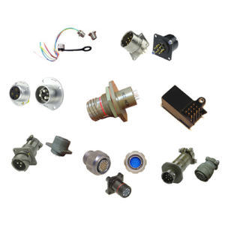

*Cinch Mil/Aero Mil-Spec Circular Connectors*

Both custom and COTS (commercial off-the-shelf) connectors are available in a variety of form factors, such as circular, rectangular/strip, and technology standard form factors such as USB, Ethernet and D-sub.

UAVs for defense applications may require OEMs (original equipment manufacturers) to meet certain standards. MIL-SPEC or MIL-STD connectors are rated to meet these specifications for factors such as vibration, durability, corrosion and temperature. These connectors are often used for larger UAVs that operate at medium or high altitudes.

Many standard connectors, such as MIL-38999 circulars and D-Subs, are too large for modern miniaturized UAVs. [Micro-](https://www.unmannedsystemstechnology.com/category/supplier-directory/electronic-systems/connectors-interconnect-technologies/micro-connectors/) and [nano-miniature](https://www.unmannedsystemstechnology.com/category/supplier-directory/electronic-systems/connectors-interconnect-technologies/nano-connectors/" \t "_blank) connectors have evolved to fill this need, offering extremely small form factors while still meeting or exceeding the mission-critical requirements for UAVs. The smallest of these connectors are built around a 0.025” pitch.

#### **Coupling and Locking Methods**

Many connectors operate using a [push-pull](https://www.unmannedsystemstechnology.com/category/supplier-directory/electronic-systems/connectors-interconnect-technologies/push-pull-connectors/) mechanism, and [circular connectors](https://www.unmannedsystemstechnology.com/category/supplier-directory/electronic-systems/connectors-interconnect-technologies/circular-connectors/) may have a screw threading or bayonet locking system to prevent unmating of the plug and receptacle in high-vibration conditions. The most durable connectors are capable of withstanding thousands of mating cycles.

[Latching connectors](https://www.unmannedsystemstechnology.com/category/supplier-directory/electronic-systems/connectors-interconnect-technologies/latching-connectors/) are ideal for applications such as UAV batteries, data storage modules or other components that may need to be swapped out quickly in order to get the UAV airborne again as soon as possible. These connectors need to be easy to operate, durable, and in the case of battery interconnects, capable of handling high currents.

Connectors with unique keying for mating pairs allow for prevention of user errors such as cross-mating or mis-mating, which may permanently damage the connector or cause a system to malfunction. This is a particular concern for larger modern unmanned vehicles, which can have a large variety of sensors and subsystems and thus very complex interconnections.

#### Connector Materials and Construction

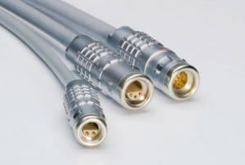

*Ruggedized Push-Pull Connectors for UAVs*

The shell material used for connector bodies is an important consideration, as it provides both protection and strength but will add weight to the overall connector. Generally, connectors are available with plastic or metal shells. Metalized composite shells are also available, providing a lightweight yet durable option, helping to reduce the overall weight of an unmanned aircraft. Aluminium is commonly used in higher-end components and provides EMC protection.

Connector backshells are available in a variety of different forms for specific applications such as panel mount, inline and right-angled. They may provide strain relief for the cable as well as EMI (Electromagnetic Interference) protection.

Connectors for cables that may carry high-speed signals need to be carefully designed to prevent signal degradation, ensuring that there is good continuity between plug and receptacle. EMI/EMP (Electro-Magnetic Interference/Electro Magnetic Pulse) issues also need to be taken into account, for instance by designing a backshell that allows clean contact with the metal braid used for terminating cables, and using decoupling to minimise crosstalk.

Connector Types

#### Fischer Connectors

[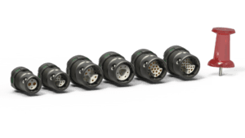](http://www.fischerconnectors.com/global/en/products/minimax?utm_source=unmannedsystemstechnology.com&utm_medium=referral)Fischer Connectors is a manufacturer of high-performance connectors and cable assembly solutions for rugged and mission-critical applications. The [Fischer MiniMax™ Series](https://www.fischerconnectors.com/uk/en/products/minimax) is a range of high-density lightweight miniature connectors available in three latching systems: push-pull, screw lock and quick release.

#### Cinch Connectivity Solutions

Cinch Connectivity Solutions is a leading supplier and manufacturer of ultra-reliable connectivity solutions. Ideal for OEMs and systems integrators of drones and robotics, the Cinch Connectivity product range has been integrated into unmanned vehicle subsystems including power, flight controls, communications, guidance systems and imaging/radar/SIGINT payloads.

#### Omnetics Connector Corporation

Omnetics Connector Corporation provide high-reliability nano- and micro-miniature connectors and interconnection solutions for UAVs that are lightweight, compact, and durable.

Their wide range of [Nano Connectors](https://www.omnetics.com/products), including circular, strip, bi-lobe and polarised varieties, features a military specification-compliant Flex-Pin contact system, spaced on 25 mil (0.64 mm) centerlines.

#### TE Connectivity

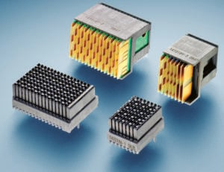

TE Connectivity produce lightweight, rugged interconnect technologies for unmanned vehicles operating in the air (UAV), on land (UGV) and underwater (UUV).

The TE Connectivity product range features Fiber Optic connection solutions and PCB backplanes, modules and connectors, alongside the SEACON series which comprises subsea connector solutions for harsh offshore environments.

Specialising in high performance, SWaP optimised and MIL-STD connectors, they manufacture circular, rectangular, nano-miniature and Micro-D connectors designed to absorb high levels of vibration, shock and impact.

#### Nicomatic

[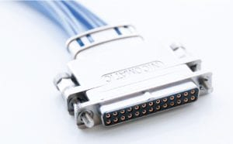](http://www.nicomatic.com/product-83.htm?utm_source=unmannedsystemstechnology.com&utm_medium=referral)

Nicomatic is a designer and manufacturer of electronic connectors and cables for power, information and video transmissions in UAVs and other robotics and weapon systems. Their lightweight DLMM metalised composite-shell connectors are designed for weight-and space-constrained UAV applications and provide superior EMI protection performance.

The EMM range of Rugged Micro Connectors is built around a 1.27mm pitch and has been designed to meet the performance requirements of MIL 83513 and withstand harsh unmanned systems environments. These connectors are ideal for applications where component size and weight are critical factors.

**Drone Frame**

it's made of Carbon, Wood, Metal, Plastic or Fiberglass the frame is **the thing that holds your Drone together**. Without it, you simply would not be able to take to the sky.

Drone stabilizes its flight using an electronic sensor and control system. There are three types of quadcopters - **Plus shape quadcopter, Cross shape quadcopter, and H shape quadcopter**. All the shapes are stable in forward flight, but quadcopter requires a yaw control input in forward flight.

Drone frames **keep the drones together**  
  
Once the drone larvae are capped, the beekeeper can remove these cells and destroy them. ... By using two drone traps per hive, and cutting out the drone larvae once a month/frame, mite populations can be drastically reduced. I recommend putting one in the #3 position.

Basically, the drone frame is the most important to build a drone. It helps to mount the motors, battery, and their parts on it. If you want to build a copter or a glide, you first need to decide what frame you will buy or build. For example, if you choose a tricopter, your drone will be smaller, the number of motors will be three, the number of propellers will be three, the number of ESC will be three, and so on. If you choose a quadcopter it will require four of each of the earlier specifications. For the gliding drone, the number of parts will vary. So, choosing a frame is important as the target of making the drone depends on the body of the drone. And a drone's body skeleton is the frame. In this book, we will build a quadcopter, as it is a medium size drone and we can implement all the things we want on it.

Always choose a material which light but strong (carbon fiber) but high cost, to save some money then choose strong plastic frames or acrylic frames.

if you build a frame by yourself. The thrust of the motor after mounting on the frame is really important. It will tell you whether your drone will float in the air or fall down or become imbalanced. To calculate the thrust of the motor, you can follow the equation that we will speak about next.

If *P* is the payload capacity of your drone (how much your drone can lift. Let *M* is the number of motors, *W* is the weight of the drone itself, and *H* is the hover throttle % (will be explained later). Then, our thrust of the motors *T* will be as follows:



The drone's payload capacity can be found with the following equation:

P = TxMxH - W

*Remember to keep the frame balanced and the center of gravity*

*remains in the hands of the drone.*

Types of Drone Frames

* 1. Monocopters: It has only one motor and using a single motor, we can move our drone in upward and downward directions only. Monocopters are ruled out by this basic concept since an airflow difference cannot be created to direct the drone. The drone will lift off and fly, but yaw, rudder, and roll motions are not possible for monocopter. Increasing the number of motors also helps to stabilize the drone. If additional motors, more wings are added, and the angle between the arms is lowered, this results in more airflow. Higher motors lift more weight capacity, which means you can carry more gear with your drone.
  2. Bicopters: Bicopters typically have two fixed-pitch propellers, one clockwise (CW) and the other counterclockwise (CCW). Control is achieved by varying the speed of each rotor independently and it is possible to generate a desired total thrust. Place the center of thrust both laterally and longitudinally, and create a desired total torque, or turning force, by altering the speed of each rotor.

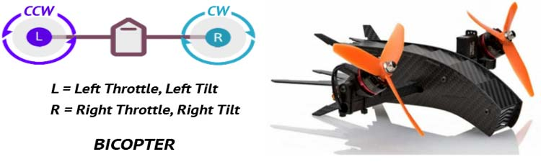

* 1. Tricopter

Tricopters typically have three fixed-pitch propellers. These can fly in more directions than bicopters and can also carry a substantial load. Tricopters have three motors in a Y or T configuration, with the motors sitting in the distal part of the limbs. If you get your hands on a tricopter, you'll notice that it has a lot more stability than a bicopter because of the extra blade. Although, even in a light breeze, a tricopter can become unsteady. Tricopters are more stable than quadcopters, but they lack the speed and performance of quadcopters.

Tricopters are of two types - Y shape tricopter and T shape tricopter.

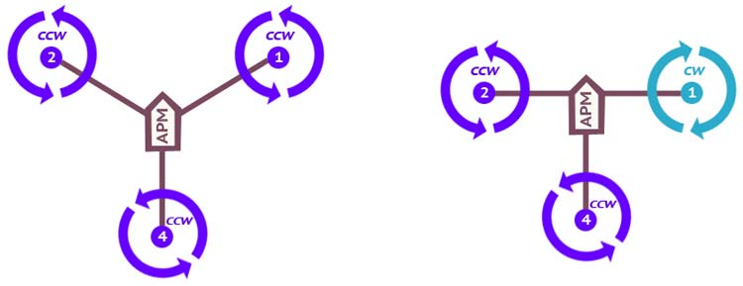

* **Advantages**: Different "look" for a UAV. Flies more like an airplane in forward motion. Price is theoretically lowest among those described here since it uses the fewest number of brushless motor (and ESC).
* **Disadvantages**: Since the copter is not symmetric, the design uses a normal RC servo to rotate the rear motor and as such, the design is less straightforward than many other multi-rotors. The rear arm is more complex since a servo needs to be mounted along the axis. Most, though not all flight controllers support this configuration.
  1. **Quadcopter**

The quadcopter is indeed the most popular multi-copter. Everyone loves quadcopter, whether it's a DIY maker or a professional drone manufacturer because it's been demonstrated that four is the optimal number for balancing price, performance, stability, and flying time. A quadcopter is a multi-rotor drone with 4 motors attached. This Drone stabilizes its flight using an electronic sensor and control system. There are three types of quadcopters - Plus shape quadcopter, Cross shape quadcopter, and H shape quadcopter.

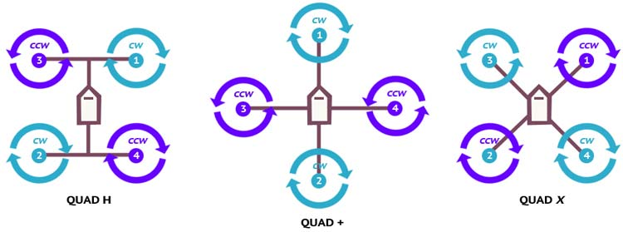

All the shapes are stable in forward flight, but quadcopter requires a yaw control input in forward flight. Yaw control authority is identical for all configurations but the pitch and roll control authority is about 30% greater in the case of cross configuration. H-frame drones were the first and the most popular drones. They can handle a lot of FPV gear while running on a [LiPo battery](https://circuitdigest.com/article/calculating-the-energy-run-time-and-charge-of-a-drone-lipo-battery). They feature a wider base, which ensures that they roll steadily. H-frame drone batteries tend to survive longer since their location prevents them from being readily damaged. It's also the best drone frame for racing because it has lots of room for easy construction and changes.

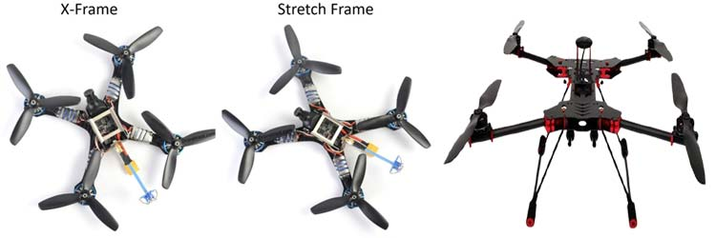

* **Advantages**: Most popular multi-rotor design, simplest construction and quite versatile. In the standard configuration, the arms / motors are symmetric about two axes. All flight controllers on the market can work with this multirotor design.
* **Disadvantages**: There is no redundancy, so if there is a failure anywhere in the system, especially a motor or propeller, the craft is likely going to crash.
  1. **Hexacopter**

The hexacopter has six propellers that are placed in a circle around the hexacopter's main body. The machine's bottom has a pair of leg-like appendages that allow it to land safely on the ground. Because of its six propellers, the quadcopter is a more powerful flyer than the quadcopter and can carry bigger loads. The hexacopter has a substantial advantage that even if one of the propellers fails, the craft can still fly because of the other five propellers. This implies that if one of the propellers fails, the drone will not crash to the ground, causing damage to the equipment attached to it. The contraption will not be able to fly if two propellers fail, but it will stay stable enough to land safely.

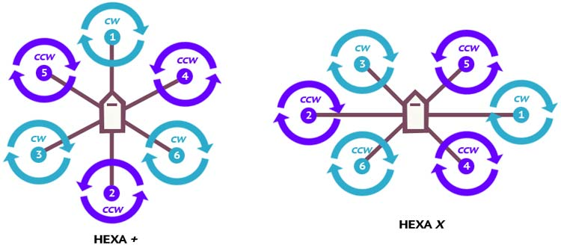

* **Advantages**: It is easy to add two additional arms and motors to a quadcopter design; this increases the total thrust available, meaning the copter can lift more payload. Also, should a motor fail, there is still a chance the copter can land rather than crash. Hexacopters often use the same motor and support arm, making the system "modular". Almost all flight controllers support this configuration.
* **Disadvantages**: This design uses additional parts, so compared to a quadcopter which uses a minimum number of parts, the equivalent hexacopter using the same motors and propellers would be more expensive and larger. These additional motors and parts add weight to the copter, so in order to get the same flight time as a quadcopter, the [battery](https://www.robotshop.com/en/uav-drone-power-wiring.html) needs to be larger (higher capacity) as well.
  1. **Octocopter**

This is the drone with eight propellers and is significantly more powerful than either a quadcopter or a hexacopter. In comparison to previous drones, these can fly higher, move faster, and carry heavier payloads. The octocopter is also extremely steady in the air, allowing it to capture footage with high-quality graphics and minimal shaking. These are considered the cream of the crop when it comes to drones because of their high performance value. They're utilized for highly specialized tasks that may require them to travel through rain or heavy gusts. The machine's robustness allows it to withstand severe weather without being thrown off course. Even if two or three propellers are destroyed, the drone will continue to fly.

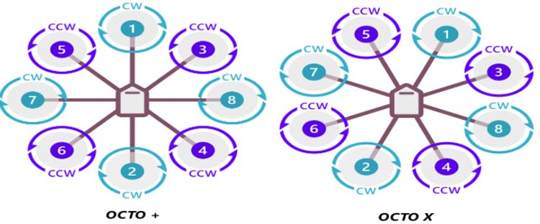

When it comes to attaching costly cameras or delicate cargo to drones, the octocopter is the greatest option because it has the best chance of keeping the payload secure and completing the job on schedule. The octocopter is frequently used in movies and television shows that require high-altitude shots. Because the equipment is so enormous, keeping it in your home might be a hassle. Additionally, caution should be exercised when carrying the drone in your car or truck to avoid damage. Because the octocopter consumes a lot of power, it can't stay in the air for very long before needing to land to recharge. If you want to use the octocopter, keep extra batteries in case the drone runs out of power before the job is finished.

**OCTO +**

* **Advantages**: More motors = more thrust, as well as increased redundancy.
* **Disadvantages**: More motors = higher price and larger battery pack. When you reach this level. most users are looking at very heavy payloads such as DSLR cameras and heavy gimbal systems. Given the price of these systems, added redundancy is really important.

**OCTO8**

* **Advantages**: More motors = more thrust, as well as increased redundancy. Rather than using fewer yet more powerful motors, octocopters provide added redundancy in the event of a motor failure.
* **Disadvantages**: More motors = higher price and larger battery pack. When you reach this level. most users are looking at very heavy payloads such as DSLR cameras and heavy gimbal systems.

**Frame Guidelines**

Step 1: See what materials and machining processes you have at your disposal.

* If you do not have much as far as machining capabilities, are not comfortable with tools, or simply want a more professional frame, then consider purchasing a [frame kit](https://www.robotshop.com/en/uav-drone-frames-mechanics.html)
* A decent frame can be made with basic tools and materials, but determining areas where it may be structurally weak, resonate (cause vibration) or may be misaligned take a keen eye and experience
* If you plan to create a custom frame, take into consideration all of the mounting which needs to be done; motors, electronics etc. and plan accordingly.

Step 2: List all of the additional (non-essential) parts you plan to add

* Additional items might include: one, two or three axis camera gimbal, [parachute](https://www.robotshop.com/en/catalogsearch/result/?q=parachute&order=stats_sales_order_count&dir=desc), onboard [mini computer](https://www.robotshop.com/en/single-board-computers.html" \o "single board computer" \t "_blank), payload, long-range electronics (tend to be larger / heavier), floatation etc.
* This list of additional / non-essential parts will give you an idea of the size of drone you will need, and add to the total weight calculation (to be done later)

Step 3: Get a rough idea of the size of frame you want

* A larger frame does not necessarily make the drone more capable, and a smaller frame does not mean the drone will be any less expensive
* A drone between 400 and 600mm is suggested for beginners

Step 4: Design, build and test the frame

* If you opted to purchase a frame kit, you should not have much to worry about in regards to durability / rigidity / assembly
* If you chose instead to design and build your own frame, it's important to test its durability, check the weight and see if it can withstand vibration (minimal flex)
* Consider using a CAD software (many are free such as Google Sketchup) to design the frame and ensure dimensions are correct

**Conclusion**

As per the types, the drone has its own set of advantages and disadvantages. While the quadcopter is inexpensive and small in size which makes it ideal for amateurs and carrying small electronics, it lacks the strength to handle greater payloads. The hexacopter is more stable and can continue to fly even if one of its motors fails. It can also fly higher and carry heavier payloads than a quadcopter. Finally, the octocopter is the most powerful of the three drones and is capable of reaching enormous heights while transporting large cargoes. However, it is the most expensive drone to purchase and requires continual charging. Now that you know the advantages and disadvantages of each type of drone, you can choose the one that best suits your requirements and provides the level of service you seek while staying within your budget.

MCQ-1 (28/01/2022)

* 1. Drone stands for \_\_\_
     1. **Dynamic Remotely Operated Navigation Equipment**
     2. Dynamic Remote Operation Navy Equipment
     3. Device for Remote Operation in National Emergency
     4. Dynamic Remotely Operating National Equipment
  2. What is a drone?
     1. Programme Controlled Device
     2. Remote Control for Device
     3. **Remotely Controlled Device**
     4. Flying vehicle
  3. What is another name for drones?
     1. Advanced Aerial vehicle
     2. Four winged flying vehicle
     3. **Unmanned aerial vehicle**
     4. Unmanned Flying Vehicle
  4. Pitch motion is based on the speed of
     1. Front Up and Rear Low
     2. **Front Low and Rear Up**
     3. Front Up and Rear Up
     4. Front Low and Rear Low
  5. YAW motion can performed in Quadcopter by
     1. **One motor slow down**
     2. Two motor slow down
     3. Three motor slow down
     4. Four motor slow down
  6. Force Dynamic algorithm ensures \_\_\_\_\_
     1. Pitch and Yaw
     2. Yaw and Thrust
     3. Thrust and Speed
     4. **Weight and Thrust**
  7. The Brain of drone is -----
     1. Propellers
     2. Magneto meter
     3. **Flight Controller**
     4. GPS
  8. Which algorithm used to bring drone to home?
     1. Homeland algorithm
     2. Kalam algorithm
     3. **Kalman algorithm**
     4. Drowit algorithm
  9. ARF stands for \_\_\_\_\_\_\_
     1. Always Ready to Fly
     2. **Almost Ready to Fly**
     3. All Ready to Fly
     4. Air Ready for Fly
  10. What is GCS?
      1. Ground Communication System
      2. Geographical Control System
      3. **Ground Control System**
      4. Global Control System

**AERODYNAMICS**

Aerodynamics is the study of forces and the resulting motion of objects through the air.

Studying the motion of air around an object allows us to measure the forces of lift, which allows an aircraft to overcome gravity, and drag, which is the resistance an aircraft “feels” as it moves through the air. Everything moving through the air (including airplanes, rockets, and birds) is affected by aerodynamics.

In this section, we will explore how lift and drag work at both [subsonic speeds](https://howthingsfly.si.edu/aerodynamics/subsonic-wings)—slower than the speed of sound—and, later, at [supersonic speeds](https://howthingsfly.si.edu/aerodynamics/shock-waves)—faster than the speed of sound.

* 1. **Air in Motion**

## FLIGHT BEGINS WITH AIR IN MOTION

As an airplane moves through the air, its wings cause changes in the speed and pressure of the air moving past them. These changes result in the upward force called **lift**. To understand lift, you first have to understand how air (a gas) behaves under certain conditions.

## BERNOULLI PRINCIPLE

Let's start with the Bernoulli principle. The Bernoulli principle states that an increase in the speed of a fluid occurs simultaneously with a decrease in the pressure exerted by the fluid.

Air pressure: 1. Normal 2. Low 3. Very Low

Why does the air speed up? Because of conservation of mass, which states that mass is neither created nor destroyed, no matter what physical changes may take place. This means that if the area in which the air is moving narrows or widens, then the air has to speed up or slow down to maintain a constant amount of air moving through the area.

## WATER ACTS LIKE AIR

You can see the Bernoulli principle at work in rivers. The water speeds up (and the pressure goes down) where the river narrows. The water slows down (and pressure goes up) where the river widens.

Static Pressure: Pressure is the continuous physical force exerted on or against an object by something (a fluid such as air) in contact with it. Static pressure is the pressure you have if the fluid isn't moving or if you are moving with the fluid. Air would press against you equally in all directions. It decreases with an increase in speed because of conservation law.

Total (ram) Pressure: Total (or ram) pressure is the pressure a fluid exerts as it is brought to a stop. Total pressure is what acts on you as you face into the wind and the air collides with your body.

Dynamic Pressure: Dynamic pressure is the pressure of a fluid that results from its motion. It is the difference between the total pressure and static pressure. Pilots rely on instruments that measure dynamic pressure to determine their airspeed.

* 1. Friction Drag

## WHAT IS FRICTION DRAG?

Friction is the resistance that happens when two things rub together—like air against an airplane. Friction is partly what causes drag.

## HOW DOES FRICTION WORK?

When an object moves through air, the air closest to the object’s surface is dragged along with it, pulling or rubbing at the air that it passes. This rubbing exerts a force on the object opposite to the direction of motion—friction drag.

The thin layer of air closest to the surface of a moving object is called the **boundary layer**. This is where friction drag occurs.

## AIR "STICKS" TO A WING

Though air is much less "thick" than, say, honey, like all fluids it has viscosity—internal friction. The air directly touching the wing does not slip past it but stays "attached" to it. The air "stuck" to the wing rubs against the air just above it, which in turn rubs against the air just above it, and so on, up to the outer edge of the boundary layer.

* 1. Vortex Drag

The spirals of air that trail off the tips of an airplane’s wings also contribute to drag. These **wing tip vortices** steal energy from the motion of the airplane, creating **vortex drag**.

WHY CAN WE SEE VORTEX LINES?

If the atmosphere has very high humidity, you can sometimes see the vortex lines on an airliner as long thin "contrails" leaving the wing tips.

## HOW DO WING TIP VORTICES AFFECT AN AIRPLANE?

The pressure imbalance that produces lift creates a problem at the wing tips. The higher-pressure air below a wing spills up over the wing tip into the area of lower-pressure air above. The wing’s forward motion spins this upward spill of air into a long spiral, like a small tornado, that trails off the wing tip. These **wing tip vortices** create a form of pressure drag called **vortex drag**.

Vortices reduce the air pressure along the entire rear edge of the wing, which increases the pressure drag on the airplane. The energy required to produce a vortex comes at the expense of the forward motion of the airplane.

Tilting the airplane’s wings upward makes the vortices stronger and increases vortex drag. Vortices are especially strong during takeoff and landing, when an airplane is flying slowly with its wings tilted upward.

## HOW DO WINGS WITH A HIGH ASPECT RATIO REDUCE VORTEX DRAG?

The farther a vortex is from the main body of the wing, the less influence it has on the wing. So long, narrow wings, like those of an airliner, or this [Lockheed U-2 spy plane](https://airandspace.si.edu/collection-objects/lockheed-u-2c/nasm_A19820380000), will produce less vortex drag than a short, stubby wing with the same surface area. But to make long wings strong enough adds weight and reduces maneuverability.

* 1. Shock Wave

## WHAT IS A SHOCK WAVE?

When an airplane travels less than the speed of sound, the air ahead of it actually begins to flow out of the way before the plane reaches it. The pressure waves created by the airplane passing through the air end up being smooth and gradual.

But as an airplane reaches the speed of sound and catches up to its own pressure waves, the air ahead of it receives no warning of the plane’s approach. The airplane plows through the air, creating a **shock wave**. As air flows through the shock wave, its pressure, density, and temperature all increase—sharply and abruptly.

When the airplane exceeds the speed of sound, a shock wave forms just ahead of the wing's leading edge. The shock wave that formed on the wing is now at the trailing edge.

When the wing is tilted upward, a **shock wave** forms below its leading edge, and an **expansion wave** forms above its leading edge. The higher pressure behind the shock wave and lower pressure behind the expansion wave result in a single force that pushes the wing up and back.

The upward part of this force is **lift**; the backward part of this force is **drag**.